**Investment Property!**

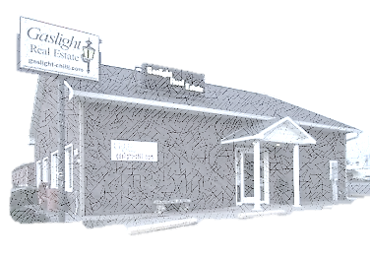

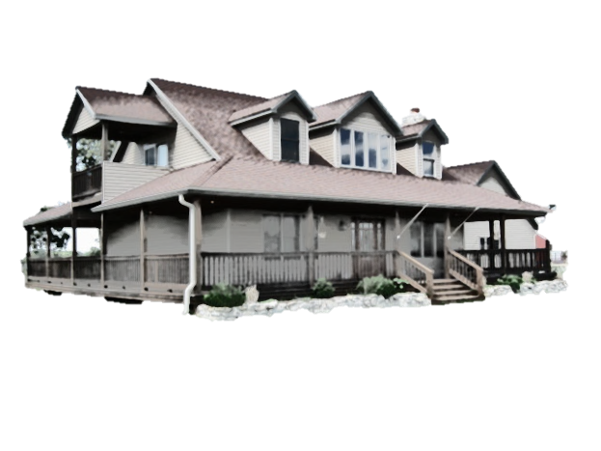

Listing broker does not guarantee the information describing these properties. Parties are advised to verify the information through personal inspection.

**Faith Keeney  
Sales Professional**

Business: 660-646-1417  
Cellular: 660-247-3409

Email: faith@gaslight-chilli.com  
 information@gaslight-chilli.com  
Website: www.gaslight-chilli.com

**Lindy Lile, Broker/Owner  
507 Park Lane  
Chillicothe, MO 64601**



|  |  |  |  |
| --- | --- | --- | --- |
| Area: | Livingston | Bathrooms: | 1 |
| Style: | Bungalow | Bedrooms: | 2 |
| Stories: | 1 | Bedroom 1: | Main |
| Square Feet: | 939 | Bedroom 2: | Main |
| Lot Size: | 51 x 137 |  |  |
| Year Built: | 1920 | Bathroom: | Main |
| Taxes: | $219.26 – 2021 |  |  |
| Garage: | Detached | Kitchen: | Main |
| Exterior: | Aluminum Siding | Family room: | Main |
| Roof: | Asphalt | Laundry: | Main |
| Heating: | Gas Stove |  |  |
| Air Conditioning: | Window Unit |  |  |
| Utility Avg: | - | Motivated Seller! Investment Property!  18 x 26 shop with electricity. Off street parking accessible from alley. | |
| Fireplace(s): | - |
| Basement: | None |
|  |  |
|  |  |

|  |  |  |
| --- | --- | --- |
| **8015/29296** | **503 Bridge St. Chillicothe** | **$39,900** |